**An Internet of Things (IoT) / Autonomous based Sewer Pipe Cleaning Robot**

**ABSTRACT**

An Internet of Things (IoT) /autonomous based sewer pipe cleaning robot is one which can be inserted into pipes and can be used to inspect the insides for blockages and clean/remove the object causing the blockage. This robot uses different sensors to detect blockages and takes necessary action to remove them. The different sensors used for this purpose are ultrasonic sensor, IR sensor and a camera. The three sensors work independently and add to the accuracy of blockage detection. Brushes and drills are integrated into the robot for the actual cleaning/object removal process. These are actuated by motors with depend on the output of the sensors. The robot can also work in fully filled pipes due to the presence of the ultrasonic and the IR sensors and a fully water proof body.

**CLAIMS**

1. The proposed design is IoT based, hence in the given claim, the sewer pipe inspection robot can be controlled manually from any given location, through the concept of Internet of Things. In this, we have designed a webpage through which assigned functions such as the robot's movement and switching cleaning motors via buttons which are displayed on the respective webpage. We can control the above functions using mobile/laptop.
2. The proposed design is capable of processing the image for obstacle detection and a live video feed, hence in the given claim, the robot is capable of detecting blockages inside the pipes. This is possible through image processing for which a camera (C.2) is mounted on the robot as shown in the below figure. The camera captures images and check for objects by use of different edge detecting algorithms and object detecting techniques possible through programming. In addition to the given claim, the robot is also capable of sending a live feed to the user which enables the user to control/drive the robot as required.
3. Manual/Automatic control is possible, so in the respective claim, the robot is capable of functioning on its own once it is inserted into the pipes and is turned on. The robot will keep doing its functions autonomously without the need of human intervention. However, if a user finds the need to control the robot manually, he may do so. When the robot is being controlled manually, the automatic functions are interrupted.
4. In this given claim remote control and monitoring is carried out, respective authorities are capable of accessing the proposed design remotely i.e. from a long distance control rooms through internet. Remote access includes controlling as well as monitoring the overall assembly.
5. In this given claim wired and wireless both control is made possible, the robot has been designed such that it can work wirelessly. The provisions of a wired functioning have also been provided in the robot.
6. Weight of the obstacle that can be removed, the robot which is made for a six inch sewer pipe can push objects up to weighing 3 kg to remove blockages. The high torque motors used in the robot are capable of removing non- breakable objects just by pushing them till the end and off the edge of the pipe.
7. The robot is capable of working in any season under any normal circumstances. There is very little effect of environmental parameters such as temperature, pressure, humidity or water flow on the functioning of the robot. The robot is encased in a plastic vessel and is hence, water proof. Also, the traction due to the material of the wheels, the torque that the motor provides and the support bar on the upper side if the robot ensure that it can maintain its position and be stable even when the water is flowing at a rate faster than normal circumstances.
8. The robot is enclosed with a support bar (C.8) at its back which allows it to maintain its position and reduce vibrations during disturbances such as exceeding flow of water above a desired limit and during drilling action. Also, the support bar enables the robot to hold its ground in tilted pipes, the maximum tilt being around 30 degrees. Hence performance of robot is not affected.
9. Curved wheels (C.9) allow a fast and easy control without any hassle. The wheels are available in three different materials (rubber, HMS, Elka) and various wheel sizes. The portfolio of the wheels was extended with the HMS (High Melting Steel) wheel, which is suitable for special use, for example in pipes with an increased ascent or in uncleaned pipes. Choose the wheel material according to the pipe surface and the intended purpose – the QCD (Quick Change Design) wheels offer all opportunities that are individually suitable for your special areas of application, comprising:

•Increased grip & smoothness

•Ideal operation characteristics in the pipe

1. The robot is encased in a plastic vessel (C.10) making it water proof, thus, preventing any damage to the robot due to the water in the pipes. The protecting body provides protection to all of the components used necessary for proper functioning of the robot.
2. Wear & tear of wheels in the given claim, the wheels (C.11) of the robot are made of such a material that its movement in the sewer pipes will have negligible negative effects on them. Thus, the problem of wear and tear of the wheels is not an issue.
3. By this proposed designed, material such as kitchen waste and sanitary waste can be removed. In the given claim, sticky waste which break the water flow in sewer pipes can be removed by proposed design.
4. In the given claim, cost of the proposed design is less than the available sewer pipe inspection and cleaning design. Here we design a robot such that it can be affordable.
5. In a proposed design brushing module (circular brushes) (C.14) are used to clean the pipe when obstacle is detected. This is how wall of pipes are cleaned effectively.
6. The drilling module (C.15) is used to clean the pipe when obstacle is detected in front of proposed design. In this drilling module is placed in front side of the robot so that it can clean the hard obstacles.

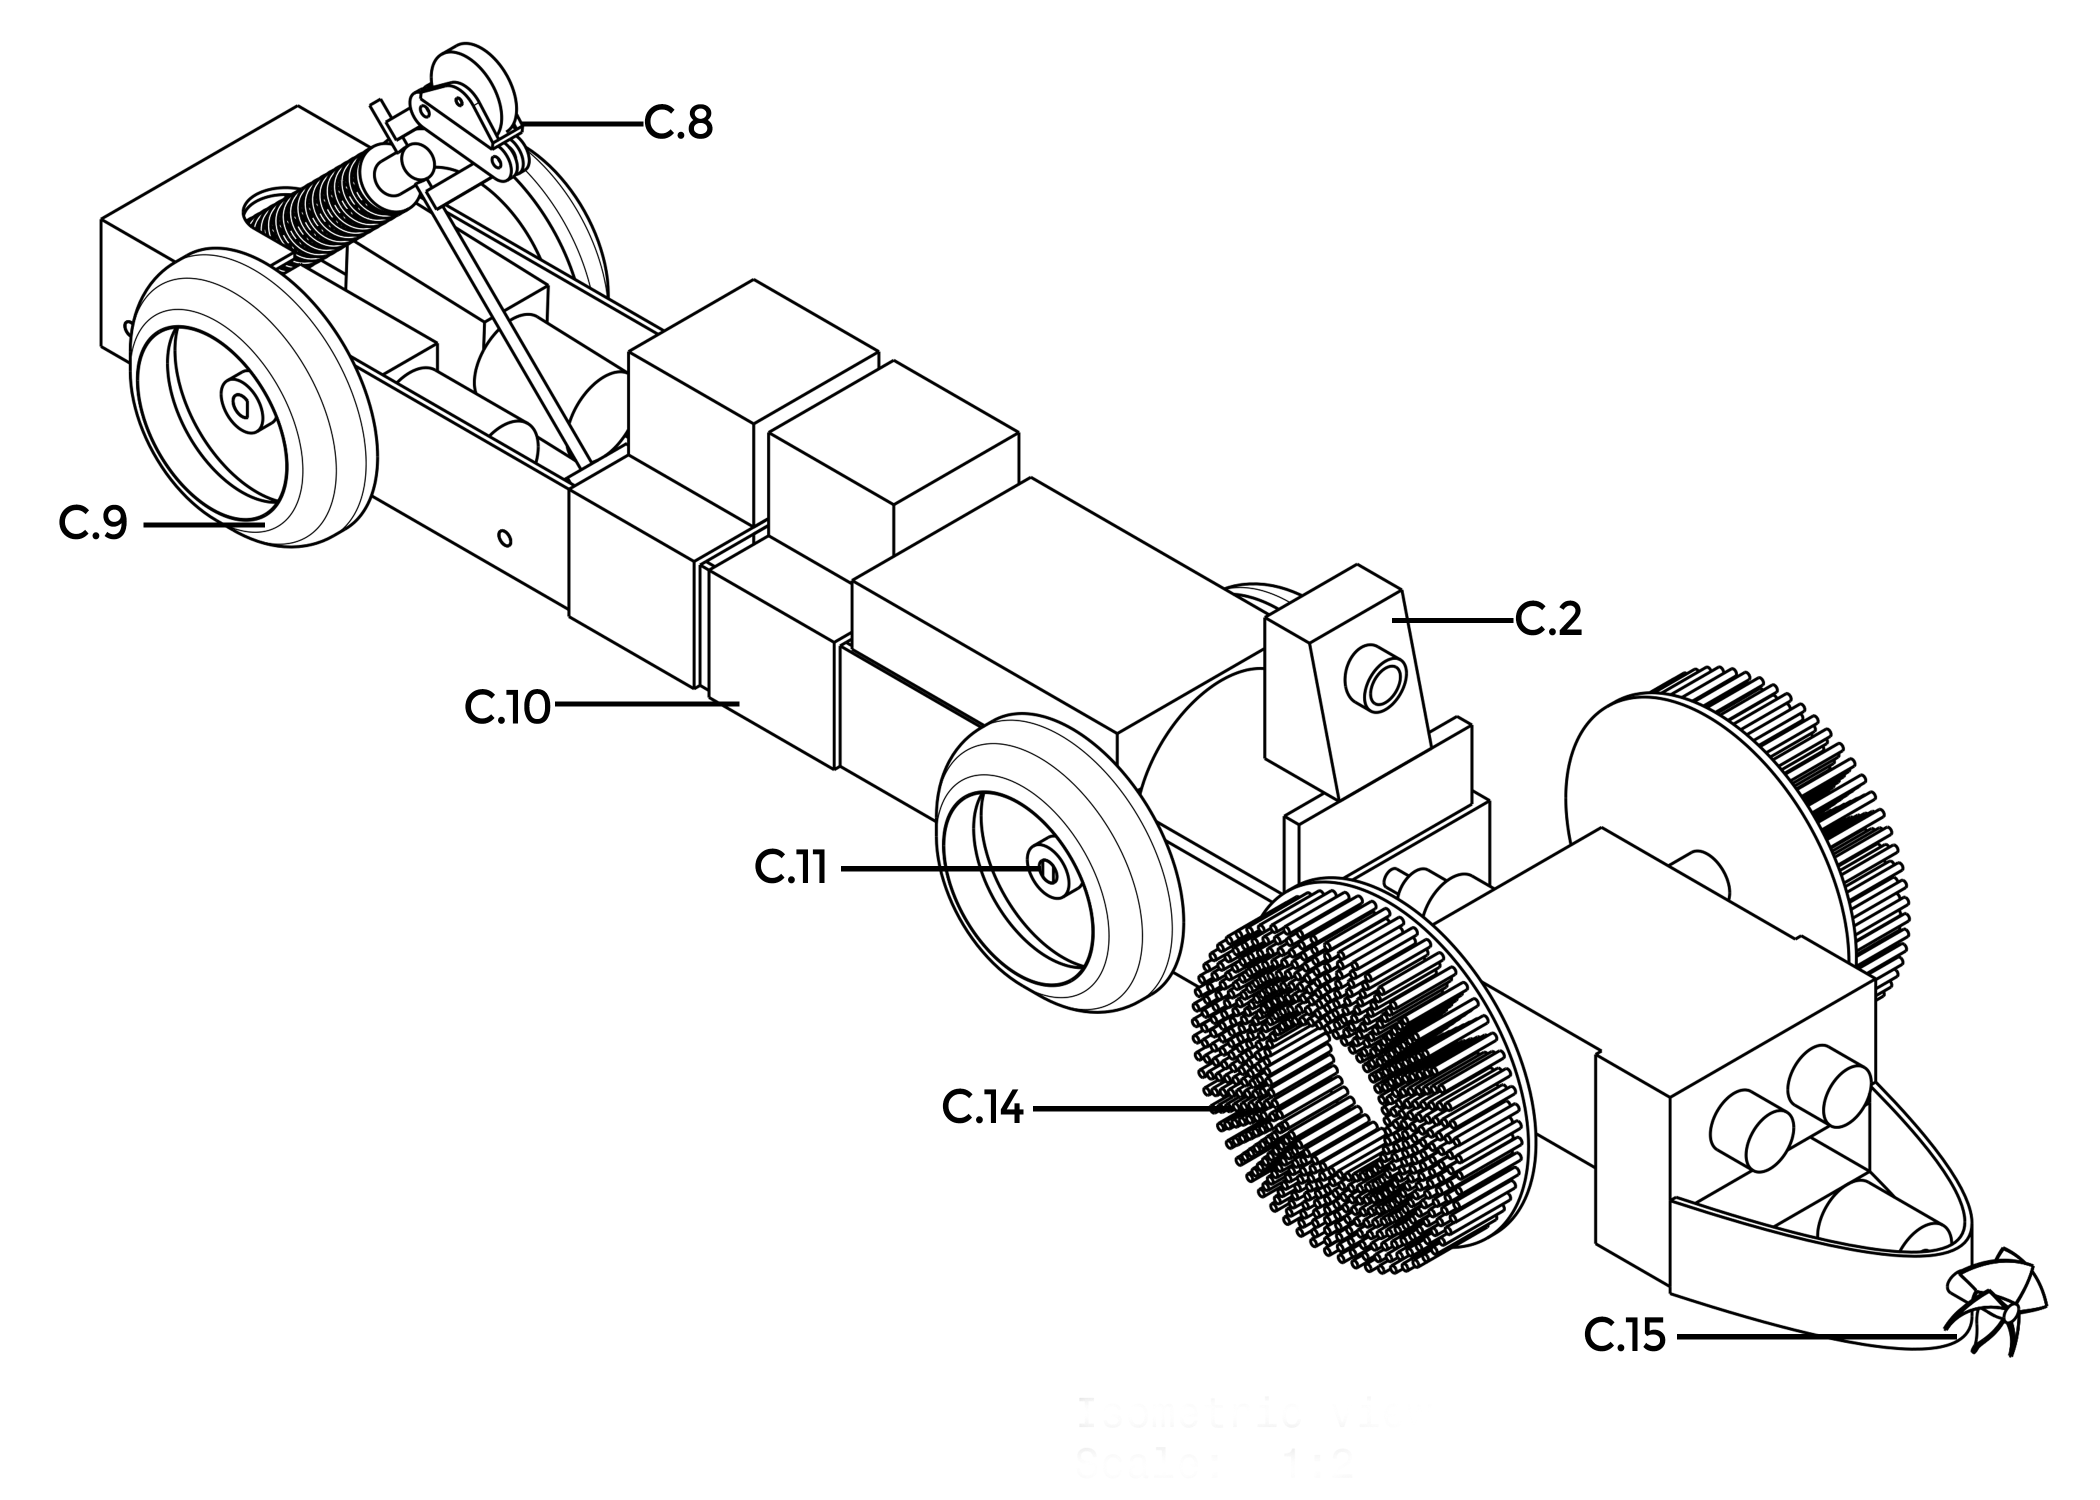

**Fig: 1: Isometric View**

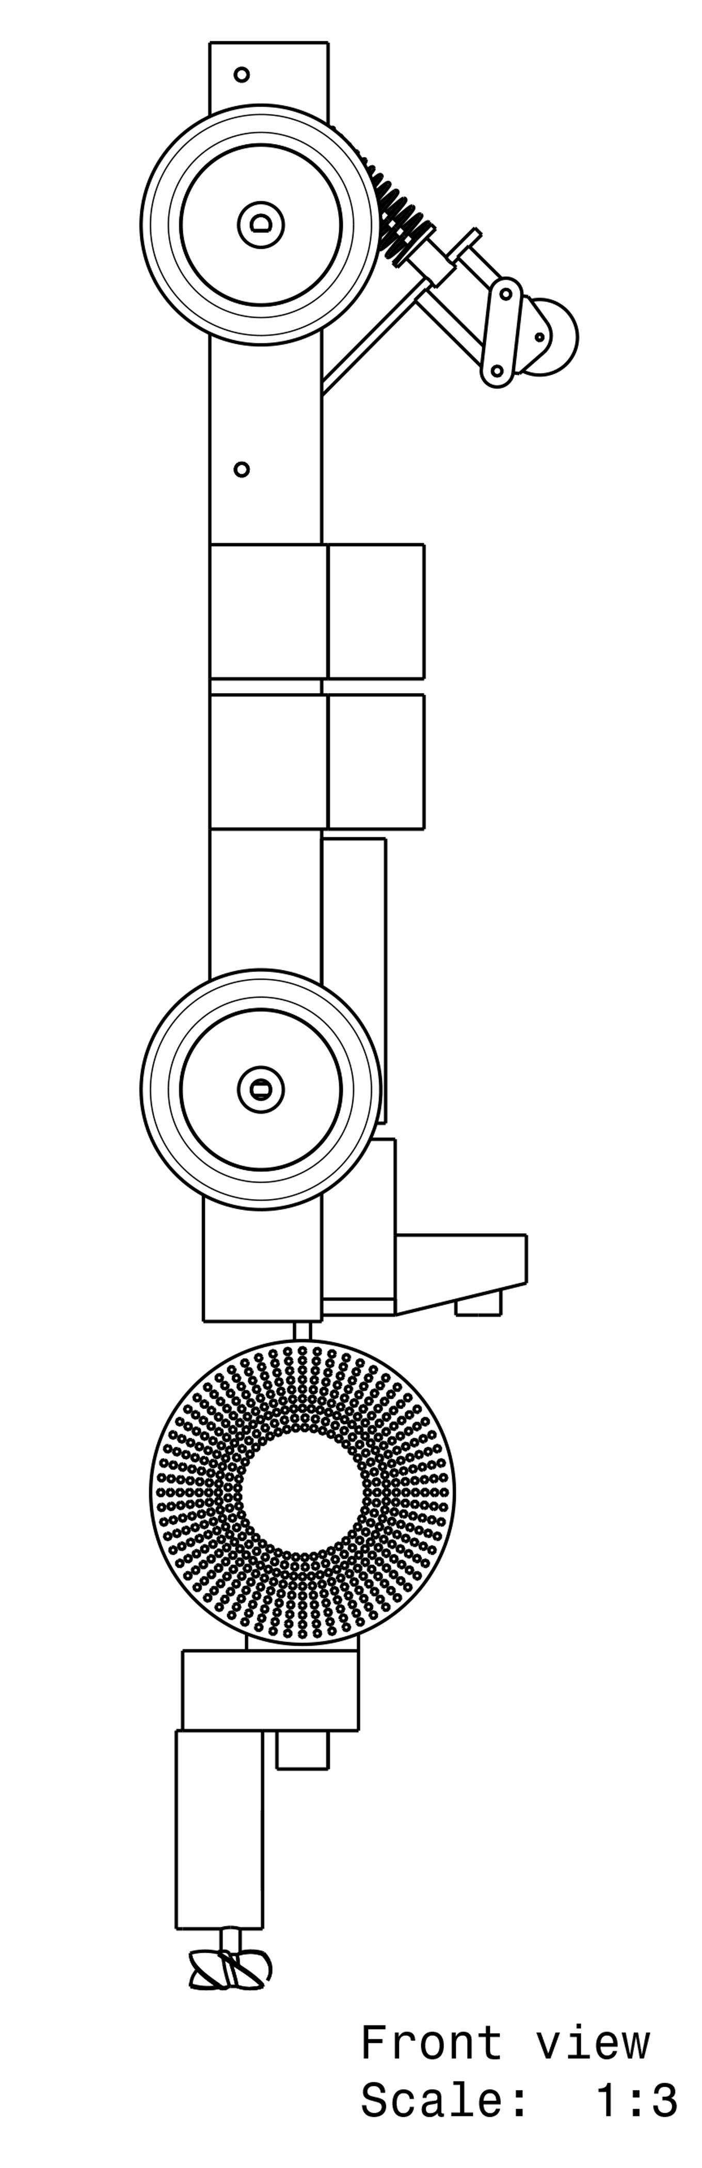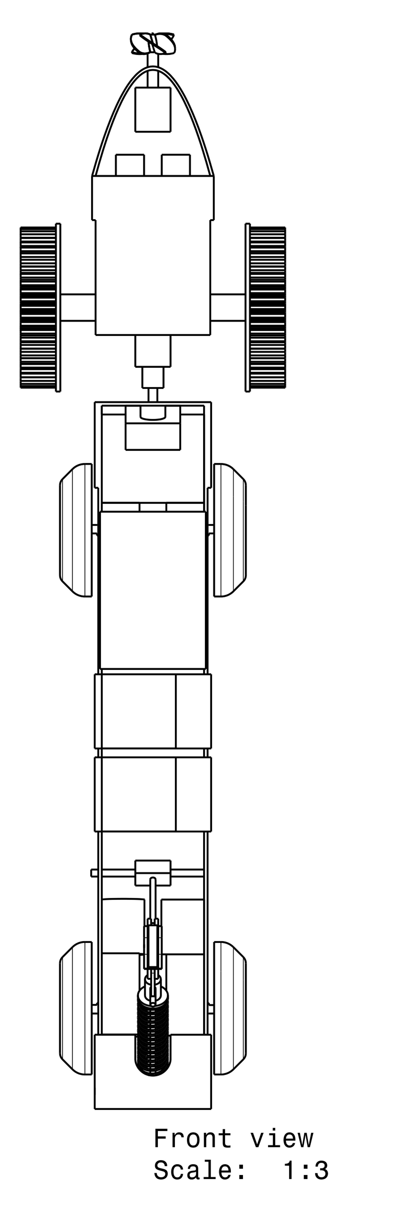

**Fig: 2: SIDE VIEW Fig3: FRONT VIEW**

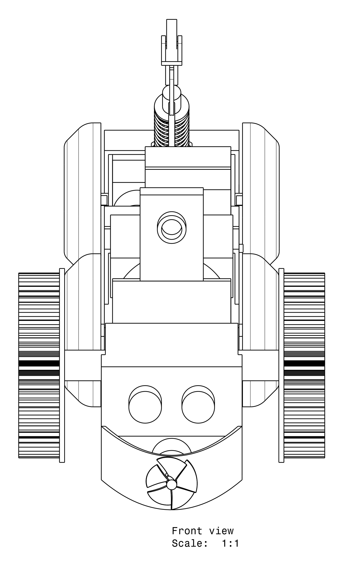

**Fig: 4: Front View**

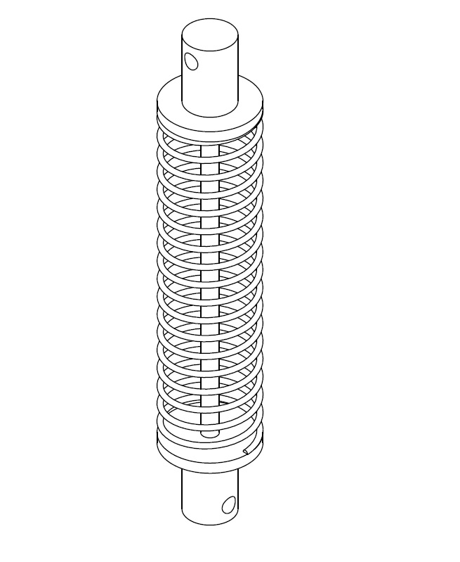

**Fig: 5: Isometric View (Suspension)**

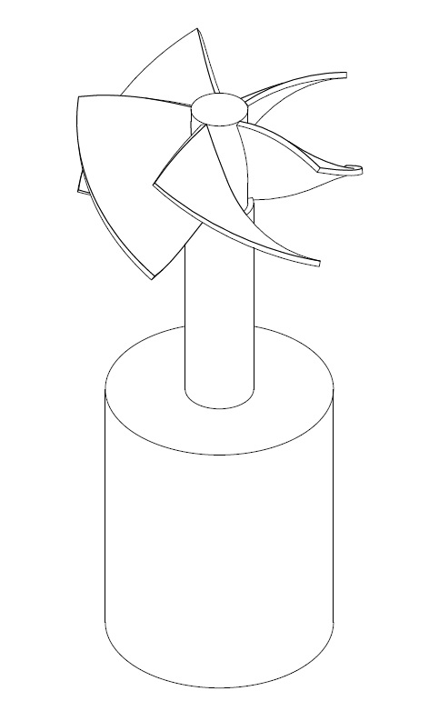

**Fig: 6: Isometric View (Propeller with Motor)**

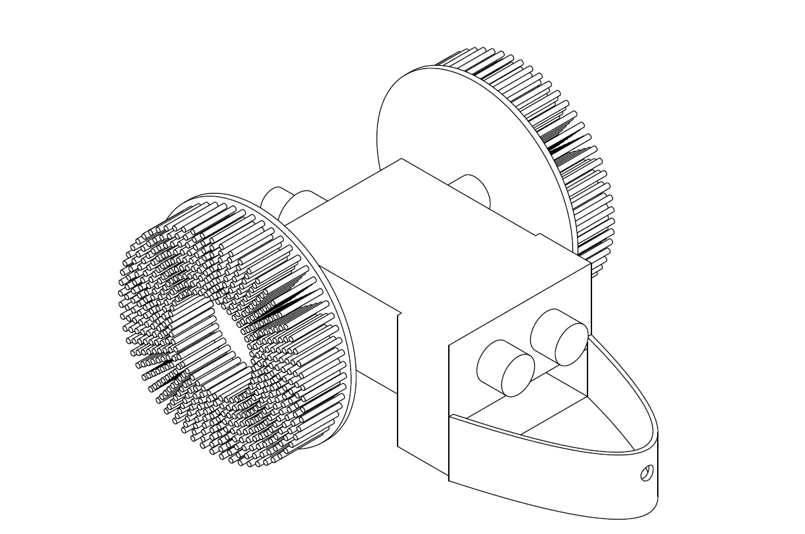

**Fig: 7: Isometric View (Front Module)**

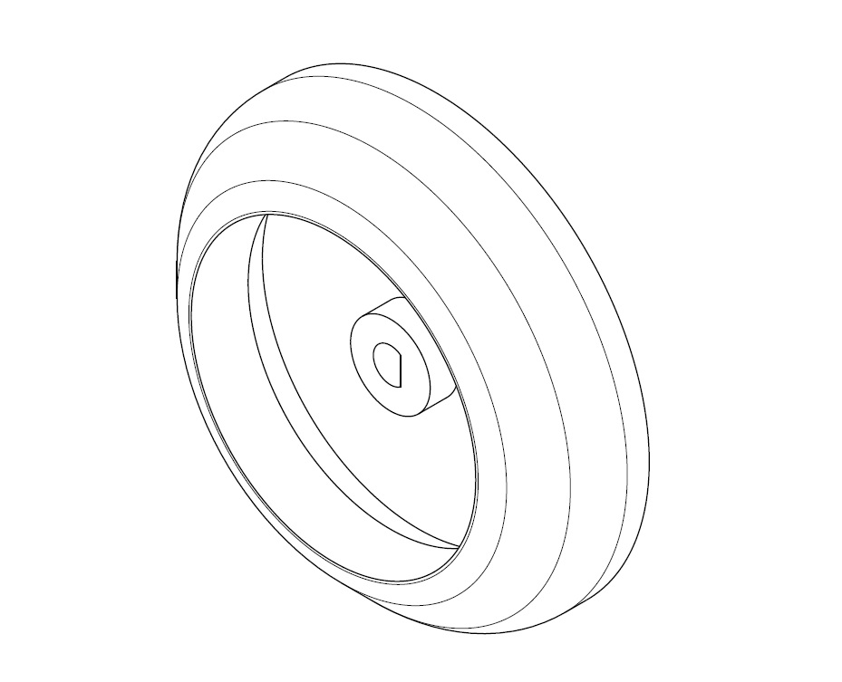

**Fig: 8: Isometric View (Wheel)**

**BLOCK DIAGRAM**

IoT

Driving Module

Brushing Module

Drilling Module

Compatible Drivers

Embedded

Control

Power Supply

Camera

Ultrasonic Sensor

Memory

IR Sensor